Nama : Vani Vabriana

Kelas : B2

NIM : 13020180086

**DOKUMENTASI PEMBUATAN FORM DATA MAHASISWA**

1. Pembuatan database dan tabel pada phpAdmin

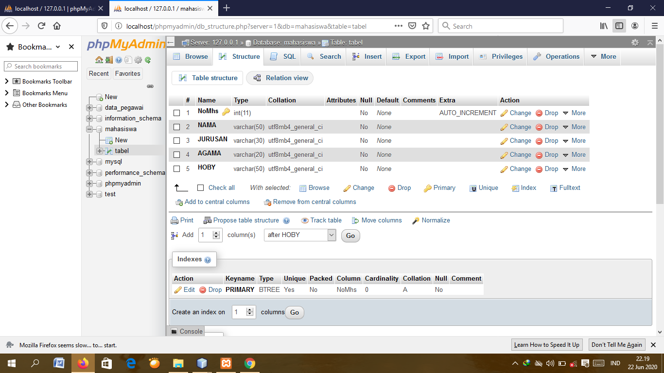

1. Membuat program untuk menghubungkan dengan database

import java.sql.Connection;

import java.sql.DriverManager;

import java.sql.SQLException;

import javax.swing.JOptionPane;

/**

*

* @author LENOVO

*/

public class koneksi {

static Connection koneksi = null;

public static Connection getConnection() {

if (koneksi == null) {

try {

String url = "jdbc:mysql://localhost:3306/mahasiswa";

String user = "root";

String password = "";

DriverManager.registerDriver(new com.mysql.jdbc.Driver());

koneksi = DriverManager.getConnection(url, user, password);

System.out.println("Terkoneksi");

} catch (SQLException t) {

System.out.println("Error membuat koneksi");

}

}

return koneksi;

}

}

Tambahkan juga bagian mysql JDBC driver agar dapat terhubung dengan database

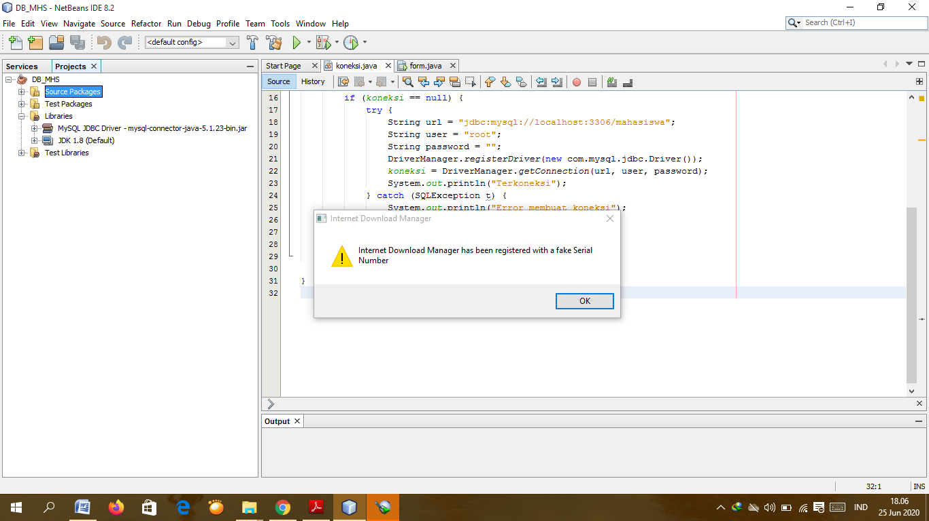

1. Pembuatan form

Pembuatan judul, tombol pada form dan pembuatan tabel untuk menampilkan data yang telah diinput di form.

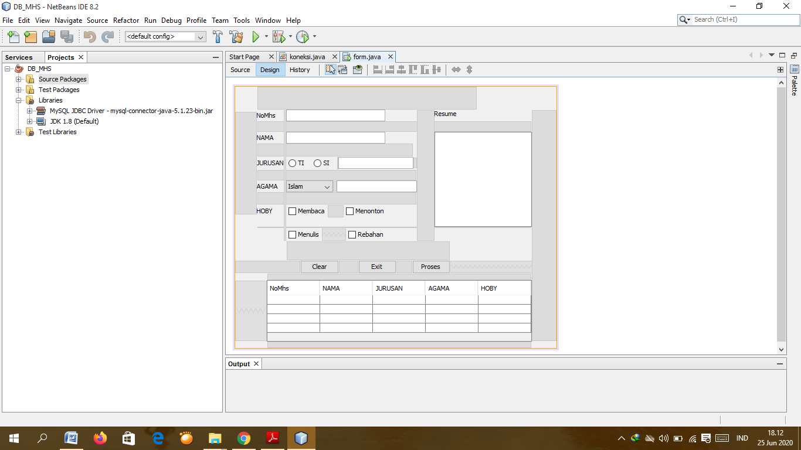

1. Sourecode

package db_mhs;

import java.sql.Connection;

import java.sql.DriverManager;

import java.sql.SQLException;

import javax.swing.JOptionPane;

/**

*

* @author LENOVO

*/

public class form extends javax.swing.JFrame {

/**

* Creates new form form

*/

public form() {

initComponents();

}

/**

* This method is called from within the constructor to initialize the form.

* WARNING: Do NOT modify this code. The content of this method is always

* regenerated by the Form Editor.

*/

@SuppressWarnings("unchecked")

// <editor-fold defaultstate="collapsed" desc="Generated Code">

private void initComponents() {

jScrollPane2 = new javax.swing.JScrollPane();

jTable1 = new javax.swing.JTable();

nim = new javax.swing.JLabel();

nama = new javax.swing.JLabel();

jLabel3 = new javax.swing.JLabel();

agama = new javax.swing.JLabel();

jLabel5 = new javax.swing.JLabel();

enim = new javax.swing.JTextField();

enama = new javax.swing.JTextField();

cbagama = new javax.swing.JComboBox<>();

hasil = new javax.swing.JTextField();

rb_si = new javax.swing.JRadioButton();

rb_ti = new javax.swing.JRadioButton();

hasilo = new javax.swing.JTextField();

cdmembaca = new javax.swing.JCheckBox();

cbmenulis = new javax.swing.JCheckBox();

cbmenonton = new javax.swing.JCheckBox();

cbrebahan = new javax.swing.JCheckBox();

jLabel1 = new javax.swing.JLabel();

jScrollPane1 = new javax.swing.JScrollPane();

bgresume = new javax.swing.JTextArea();

bgclear = new javax.swing.JButton();

bgexit = new javax.swing.JButton();

bgproses = new javax.swing.JButton();

jScrollPane4 = new javax.swing.JScrollPane();

tabel = new javax.swing.JTable();

jTable1.setModel(new javax.swing.table.DefaultTableModel(

new Object [][] {

{null, null, null, null},

{null, null, null, null},

{null, null, null, null},

{null, null, null, null}

},

new String [] {

"Title 1", "Title 2", "Title 3", "Title 4"

}

));

jScrollPane2.setViewportView(jTable1);

setDefaultCloseOperation(javax.swing.WindowConstants.EXIT_ON_CLOSE);

nim.setText("NoMhs");

nama.setText("NAMA");

jLabel3.setText("JURUSAN");

agama.setText("AGAMA");

jLabel5.setText("HOBY");

cbagama.setModel(new javax.swing.DefaultComboBoxModel<>(new String[] { "Islam", "Kristen", "Katolik", "Hindu", "Buddha", " " }));

cbagama.addActionListener(new java.awt.event.ActionListener() {

public void actionPerformed(java.awt.event.ActionEvent evt) {

cbagamaActionPerformed(evt);

}

});

rb_si.setText("SI");

rb_ti.setText("TI");

cdmembaca.setText("Membaca");

cbmenulis.setText("Menulis");

cbmenonton.setText("Menonton");

cbrebahan.setText("Rebahan");

jLabel1.setText("Resume");

bgresume.setColumns(20);

bgresume.setRows(5);

jScrollPane1.setViewportView(bgresume);

bgclear.setText("Clear");

bgclear.addActionListener(new java.awt.event.ActionListener() {

public void actionPerformed(java.awt.event.ActionEvent evt) {

bgclearActionPerformed(evt);

}

});

bgexit.setText("Exit");

bgexit.addActionListener(new java.awt.event.ActionListener() {

public void actionPerformed(java.awt.event.ActionEvent evt) {

bgexitActionPerformed(evt);

}

});

bgproses.setText("Proses");

bgproses.addActionListener(new java.awt.event.ActionListener() {

public void actionPerformed(java.awt.event.ActionEvent evt) {

bgprosesActionPerformed(evt);

}

});

tabel.setModel(new javax.swing.table.DefaultTableModel(

new Object [][] {

{null, null, null, null, null},

{null, null, null, null, null},

{null, null, null, null, null},

{null, null, null, null, null}

},

new String [] {

"NoMhs", "NAMA", "JURUSAN", "AGAMA", "HOBY"

}

));

tabel.addAncestorListener(new javax.swing.event.AncestorListener() {

public void ancestorMoved(javax.swing.event.AncestorEvent evt) {

}

public void ancestorAdded(javax.swing.event.AncestorEvent evt) {

tabelAncestorAdded(evt);

}

public void ancestorRemoved(javax.swing.event.AncestorEvent evt) {

}

});

tabel.addMouseListener(new java.awt.event.MouseAdapter() {

public void mouseClicked(java.awt.event.MouseEvent evt) {

tabelMouseClicked(evt);

}

});

jScrollPane4.setViewportView(tabel);

javax.swing.GroupLayout layout = new javax.swing.GroupLayout(getContentPane());

getContentPane().setLayout(layout);

layout.setHorizontalGroup(

layout.createParallelGroup(javax.swing.GroupLayout.Alignment.LEADING)

.addGroup(layout.createSequentialGroup()

.addGap(111, 111, 111)

.addComponent(bgclear, javax.swing.GroupLayout.PREFERRED_SIZE, 66, javax.swing.GroupLayout.PREFERRED_SIZE)

.addGap(33, 33, 33)

.addComponent(bgexit, javax.swing.GroupLayout.PREFERRED_SIZE, 65, javax.swing.GroupLayout.PREFERRED_SIZE)

.addGap(27, 27, 27)

.addComponent(bgproses)

.addContainerGap(javax.swing.GroupLayout.DEFAULT_SIZE, Short.MAX_VALUE))

.addGroup(javax.swing.GroupLayout.Alignment.TRAILING, layout.createSequentialGroup()

.addGroup(layout.createParallelGroup(javax.swing.GroupLayout.Alignment.TRAILING)

.addGroup(layout.createSequentialGroup()

.addContainerGap(javax.swing.GroupLayout.DEFAULT_SIZE, Short.MAX_VALUE)

.addComponent(jScrollPane4, javax.swing.GroupLayout.PREFERRED_SIZE, javax.swing.GroupLayout.DEFAULT_SIZE, javax.swing.GroupLayout.PREFERRED_SIZE))

.addGroup(layout.createSequentialGroup()

.addGap(37, 37, 37)

.addGroup(layout.createParallelGroup(javax.swing.GroupLayout.Alignment.LEADING, false)

.addComponent(nama, javax.swing.GroupLayout.DEFAULT_SIZE, javax.swing.GroupLayout.DEFAULT_SIZE, Short.MAX_VALUE)

.addComponent(jLabel3, javax.swing.GroupLayout.DEFAULT_SIZE, javax.swing.GroupLayout.DEFAULT_SIZE, Short.MAX_VALUE)

.addComponent(agama, javax.swing.GroupLayout.DEFAULT_SIZE, javax.swing.GroupLayout.DEFAULT_SIZE, Short.MAX_VALUE)

.addComponent(jLabel5, javax.swing.GroupLayout.DEFAULT_SIZE, javax.swing.GroupLayout.DEFAULT_SIZE, Short.MAX_VALUE)

.addComponent(nim, javax.swing.GroupLayout.DEFAULT_SIZE, javax.swing.GroupLayout.DEFAULT_SIZE, Short.MAX_VALUE))

.addGap(4, 4, Short.MAX_VALUE)

.addGroup(layout.createParallelGroup(javax.swing.GroupLayout.Alignment.LEADING)

.addGroup(layout.createParallelGroup(javax.swing.GroupLayout.Alignment.LEADING)

.addGroup(javax.swing.GroupLayout.Alignment.TRAILING, layout.createSequentialGroup()

.addComponent(rb_ti, javax.swing.GroupLayout.PREFERRED_SIZE, 43, javax.swing.GroupLayout.PREFERRED_SIZE)

.addPreferredGap(javax.swing.LayoutStyle.ComponentPlacement.RELATED)

.addComponent(rb_si, javax.swing.GroupLayout.PREFERRED_SIZE, 44, javax.swing.GroupLayout.PREFERRED_SIZE)

.addPreferredGap(javax.swing.LayoutStyle.ComponentPlacement.RELATED)

.addComponent(hasilo, javax.swing.GroupLayout.PREFERRED_SIZE, 128, javax.swing.GroupLayout.PREFERRED_SIZE)

.addGap(6, 6, 6))

.addGroup(layout.createParallelGroup(javax.swing.GroupLayout.Alignment.LEADING, false)

.addComponent(enama, javax.swing.GroupLayout.DEFAULT_SIZE, 169, Short.MAX_VALUE)

.addComponent(enim))

.addGroup(layout.createParallelGroup(javax.swing.GroupLayout.Alignment.TRAILING, false)

.addGroup(layout.createSequentialGroup()

.addComponent(cbmenulis)

.addPreferredGap(javax.swing.LayoutStyle.ComponentPlacement.RELATED, javax.swing.GroupLayout.DEFAULT_SIZE, Short.MAX_VALUE)

.addComponent(cbrebahan))

.addGroup(layout.createSequentialGroup()

.addComponent(cdmembaca)

.addGap(27, 27, 27)

.addComponent(cbmenonton))))

.addGroup(layout.createSequentialGroup()

.addComponent(cbagama, javax.swing.GroupLayout.PREFERRED_SIZE, 80, javax.swing.GroupLayout.PREFERRED_SIZE)

.addPreferredGap(javax.swing.LayoutStyle.ComponentPlacement.RELATED)

.addComponent(hasil, javax.swing.GroupLayout.PREFERRED_SIZE, 137, javax.swing.GroupLayout.PREFERRED_SIZE)))

.addGap(30, 30, 30)

.addGroup(layout.createParallelGroup(javax.swing.GroupLayout.Alignment.LEADING)

.addComponent(jLabel1, javax.swing.GroupLayout.PREFERRED_SIZE, 73, javax.swing.GroupLayout.PREFERRED_SIZE)

.addComponent(jScrollPane1, javax.swing.GroupLayout.PREFERRED_SIZE, javax.swing.GroupLayout.DEFAULT_SIZE, javax.swing.GroupLayout.PREFERRED_SIZE))))

.addGap(42, 42, 42))

);

layout.setVerticalGroup(

layout.createParallelGroup(javax.swing.GroupLayout.Alignment.LEADING)

.addGroup(layout.createSequentialGroup()

.addGap(39, 39, 39)

.addGroup(layout.createParallelGroup(javax.swing.GroupLayout.Alignment.LEADING)

.addGroup(layout.createParallelGroup(javax.swing.GroupLayout.Alignment.BASELINE)

.addComponent(nim)

.addComponent(enim, javax.swing.GroupLayout.PREFERRED_SIZE, javax.swing.GroupLayout.DEFAULT_SIZE, javax.swing.GroupLayout.PREFERRED_SIZE))

.addComponent(jLabel1))

.addGap(18, 18, 18)

.addGroup(layout.createParallelGroup(javax.swing.GroupLayout.Alignment.LEADING)

.addGroup(layout.createSequentialGroup()

.addGroup(layout.createParallelGroup(javax.swing.GroupLayout.Alignment.BASELINE)

.addComponent(nama)

.addComponent(enama, javax.swing.GroupLayout.PREFERRED_SIZE, javax.swing.GroupLayout.DEFAULT_SIZE, javax.swing.GroupLayout.PREFERRED_SIZE))

.addGap(22, 22, 22)

.addGroup(layout.createParallelGroup(javax.swing.GroupLayout.Alignment.BASELINE)

.addComponent(jLabel3)

.addComponent(rb_ti)

.addComponent(rb_si)

.addComponent(hasilo, javax.swing.GroupLayout.PREFERRED_SIZE, javax.swing.GroupLayout.DEFAULT_SIZE, javax.swing.GroupLayout.PREFERRED_SIZE))

.addGap(18, 18, 18)

.addGroup(layout.createParallelGroup(javax.swing.GroupLayout.Alignment.BASELINE)

.addComponent(agama)

.addComponent(cbagama, javax.swing.GroupLayout.PREFERRED_SIZE, javax.swing.GroupLayout.DEFAULT_SIZE, javax.swing.GroupLayout.PREFERRED_SIZE)

.addComponent(hasil, javax.swing.GroupLayout.PREFERRED_SIZE, javax.swing.GroupLayout.DEFAULT_SIZE, javax.swing.GroupLayout.PREFERRED_SIZE))

.addGap(21, 21, 21)

.addGroup(layout.createParallelGroup(javax.swing.GroupLayout.Alignment.BASELINE)

.addComponent(cdmembaca)

.addComponent(cbmenonton)

.addComponent(jLabel5)))

.addComponent(jScrollPane1, javax.swing.GroupLayout.PREFERRED_SIZE, 162, javax.swing.GroupLayout.PREFERRED_SIZE))

.addPreferredGap(javax.swing.LayoutStyle.ComponentPlacement.RELATED)

.addGroup(layout.createParallelGroup(javax.swing.GroupLayout.Alignment.BASELINE)

.addComponent(cbmenulis)

.addComponent(cbrebahan))

.addGap(32, 32, 32)

.addGroup(layout.createParallelGroup(javax.swing.GroupLayout.Alignment.BASELINE)

.addComponent(bgclear)

.addComponent(bgexit)

.addComponent(bgproses))

.addGap(11, 11, 11)

.addComponent(jScrollPane4, javax.swing.GroupLayout.DEFAULT_SIZE, 105, Short.MAX_VALUE)

.addContainerGap())

);

pack();

}// </editor-fold>

private void bgclearActionPerformed(java.awt.event.ActionEvent evt) {

// TODO add your handling code here

enim.setText("");

enama.setText("");

hasil.setText("");

hasilo.setText("");

bgresume.setText("");

}

private void bgexitActionPerformed(java.awt.event.ActionEvent evt) {

// TODO add your handling code here:

dispose();

}

private void bgprosesActionPerformed(java.awt.event.ActionEvent evt) {

// TODO add your handling code here:

int indexccombo;

String pilihan;

String jurusan;

String daftarhoby="";

indexccombo = cbagama.getSelectedIndex();

pilihan = (String) cbagama.getSelectedItem();

hasil.setText(pilihan);

jurusan = "Teknik Informatika";

if (rb_si.isSelected()){

jurusan = "Sistem Informasi";

}

else{

jurusan = "Teknik Informatika";

}

hasilo.setText(String.valueOf(jurusan));

if(cbmenonton.isSelected())

daftarhoby+=cbmenonton.getText()+"\n";

if(cbmenulis.isSelected())

daftarhoby+=cbmenulis.getText()+"\n";

if(cbrebahan.isSelected())

daftarhoby+=cbrebahan.getText()+"\n";

if(cdmembaca.isSelected())

daftarhoby+=cdmembaca.getText()+"\n";

bgresume.setText(

"NoMhs :\t"+enim.getText()+"\n"+

"NAMA :\t"+enama.getText()+"\n"+

"JURUSAN:\t"+jurusan+"\n"+

"AGAMA :\t"+pilihan+"\n"+

"HOBY :\t"+daftarhoby);

}

private void cbagamaActionPerformed(java.awt.event.ActionEvent evt) {

// TODO add your handling code here:

}

private void tabelAncestorAdded(javax.swing.event.AncestorEvent evt) {

// TODO add your handling code here:

}

private void tabelMouseClicked(java.awt.event.MouseEvent evt) {

// TODO add your handling code here:

}

/**

* @param args the command line arguments int indexccombo;

String pilihan;

String jurusan;

String daftarhoby="";

indexccombo = cbagama.getSelectedIndex();

pilihan = (String) cbagama.getSelectedItem();

hasil.setText(pilihan);

jurusan = "Teknik Informatika";

if (rb_si.isSelected()){

jurusan = "Sistem Informasi";

}

else{

jurusan = "Teknik Informatika";

}

hasilo.setText(String.valueOf(jurusan));

if(cbmenonton.isSelected())

daftarhoby+=cbmenonton.getText()+"\n";

if(cbmenulis.isSelected())

daftarhoby+=cbmenulis.getText()+"\n";

if(cbrebahan.isSelected())

daftarhoby+=cbrebahan.getText()+"\n";

if(cdmembaca.isSelected())

daftarhoby+=cdmembaca.getText()+"\n";

bgresume.setText(

"NoMhs :\t"+enim.getText()+"\n"+

"NAMA :\t"+enama.getText()+"\n"+

"JURUSAN:\t"+jurusan+"\n"+

"AGAMA :\t"+pilihan+"\n"+

"HOBY :\t"+daftarhoby);

}

*/

public static void main(String args[]) {

/* Set the Nimbus look and feel */

//<editor-fold defaultstate="collapsed" desc=" Look and feel setting code (optional) ">

/* If Nimbus (introduced in Java SE 6) is not available, stay with the default look and feel.

* For details see http://download.oracle.com/javase/tutorial/uiswing/lookandfeel/plaf.html

*/

try {

for (javax.swing.UIManager.LookAndFeelInfo info : javax.swing.UIManager.getInstalledLookAndFeels()) {

if ("Nimbus".equals(info.getName())) {

javax.swing.UIManager.setLookAndFeel(info.getClassName());

break;

}

}

} catch (ClassNotFoundException ex) {

java.util.logging.Logger.getLogger(form.class.getName()).log(java.util.logging.Level.SEVERE, null, ex);

} catch (InstantiationException ex) {

java.util.logging.Logger.getLogger(form.class.getName()).log(java.util.logging.Level.SEVERE, null, ex);

} catch (IllegalAccessException ex) {

java.util.logging.Logger.getLogger(form.class.getName()).log(java.util.logging.Level.SEVERE, null, ex);

} catch (javax.swing.UnsupportedLookAndFeelException ex) {

java.util.logging.Logger.getLogger(form.class.getName()).log(java.util.logging.Level.SEVERE, null, ex);

}

//</editor-fold>

/* Create and display the form */

java.awt.EventQueue.invokeLater(new Runnable() {

public void run() {

new form().setVisible(true);

}

});

}

// Variables declaration - do not modify

private javax.swing.JLabel agama;

private javax.swing.JButton bgclear;

private javax.swing.JButton bgexit;

private javax.swing.JButton bgproses;

private javax.swing.JTextArea bgresume;

private javax.swing.JComboBox<String> cbagama;

private javax.swing.JCheckBox cbmenonton;

private javax.swing.JCheckBox cbmenulis;

private javax.swing.JCheckBox cbrebahan;

private javax.swing.JCheckBox cdmembaca;

private javax.swing.JTextField enama;

private javax.swing.JTextField enim;

private javax.swing.JTextField hasil;

private javax.swing.JTextField hasilo;

private javax.swing.JLabel jLabel1;

private javax.swing.JLabel jLabel3;

private javax.swing.JLabel jLabel5;

private javax.swing.JScrollPane jScrollPane1;

private javax.swing.JScrollPane jScrollPane2;

private javax.swing.JScrollPane jScrollPane4;

private javax.swing.JTable jTable1;

private javax.swing.JLabel nama;

private javax.swing.JLabel nim;

private javax.swing.JRadioButton rb_si;

private javax.swing.JRadioButton rb_ti;

private javax.swing.JTable tabel;

// End of variables declaration

}

1. Run Program

